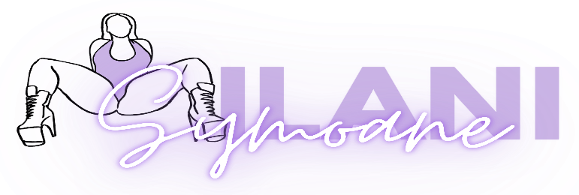
Participant Consent and Waiver of Liability for Milani Symoane LLC Participation

FULL NAME _______________________________________________________________ DOB ____________________
EMAIL ADDRESS _______________________________________________PHONE _______________________________
[Initial Below]
In consideration of my being allowed to participate in the programs of Milani Symoane, LLC and/or to use its equipment, I agree to the following waiver and release:
I _____ hereby certify that I am at least 18 years of age. I give my consent for the above-named participant to participate in the activates/classes/parties/showcases/event(s), etc. I, the undersigned, hereby release and discharge Milani Symoane LLC, including their owner, employees, instructors, participants, volunteers, agents, assistants, students and facilities from any and all liability arising out of or in connection with the above described activity or all liabilities associated with any and all claims related to such. Meaning all claims, demands, losses, causes of actions, suits or judgements of any and every kind that occur during activities conducted by Milani Symoane LLC (not limited to: dance, aerial/pole, and fitness, etc.) and that result from any cause including the active or passive conduct and /or negligence of Milani Symoane LLC and its owner, employees, instructors, guest instructors, participants, volunteers, agents assistants, and students.
I _____ acknowledge on my behalf that there are risks that are inherent in the above-described activity, including the risk of serious injury, permanent disability or even death that may occur throughout the conduct of other participants, instructors, staff, including conduct that may not be part of the ordinary risks of the activity itself. For example, injury, permanent disability or even death may occur through conduct that is not authorized by the rules and regulations of the activity. This release and waiver as set forth in the above paragraph shall also apply to this type of conduct and any resulting injury, loss, damage, injury or death. Milani Symoane LLC and its affiliates are not responsible for any personal property damage/loss, which may occur on the premises before, during or after any classes, workshop, rehearsal, party, private, performance, or activity.
I _____ understand permission is granted to Milani Symoane to use photographs & video recordings of students and guests for publicity purposes.
I _____ understand no outside videography or photography is prohibited in all “The Opulent Affair” live performances, unless explicitly stated. I understand that if I choose to violate this condition, I may be ejected from the event venue and not be allowed reentry or refund of my ticket purchase.

In addition to above, I understand and acknowledge that:
Payment is required in advance for all events, classes, workshops etc. There will be no makeup classes, workshops, parties, performances or activities unless otherwise stated by Milani Symoane LLC. Payments for all the above are non-refundable and non-transferable. An 8-hour cancellation notice is required for all classes and privates, or the session cannot be rescheduled to a later available time, and the undersigned will be responsible for the cost of that session.

I HAVE CAREFULLY READ AND UNDERSTAND THIS ENTIRE AGREEMENT AND AGREE TO ALL OF THE ABOVE TERMS AND CONDITIONS and understand that by signing this document that I have given up substantial and ALL rights for the named participant/myself, relatives/non- relatives, associates, facilitators, personal representatives, administrators trustees, and any other covered party.

_____________________________________ _____________________________________ _____________________
Print Name Participant’s Signature Date

